**SEIS 610 -03 –Software Engineering:**

**Meal Picker App**

**by:**

**Uma Krishnaraju**

**Angela Holden**

**Brenda Canales**

**Anil Kumar Reddy**

**Elaboration Part 1**

|  |  |  |
| --- | --- | --- |
| **Version** | **Status** | **Version Date** |
| **1.0** | **Draft** | **2/26/2020** |

1. **Play Characters**

*Name Character Title Responsibility*

1. Brenda Calories (user) using program for calorie intake (human)

2. Angela Macros (user) using program for macros calculation (human)

3. Uma Admin (operator) Manages users input/profiles

4. Anil Storage (manager) Saves and gathers info

5. Darlene User Info (security) Validates user login info

6. Danny Display (designer) Presents the list of selections to user

7. Kat Nutrition API (data) Manages data and categorizes

1. **Setting**

Focusing on two users, once for each selection, which need to first create accounts, enter their information chosen (calories or macros), info needs to be processed and stored in their profiles, information needs to be processed through the Nutrition API, then funneled through the meal info storage in order to display meal options.

1. **Narration**

Angela: Hey Brenda, I found a new app that can track our calories or macros and   
help us decide what to eat, you want to try it with me?

Brenda: That sounds like a great idea, I want to focus on my calorie intake and   
you can use your macros allocation.

Angela: Seems fairly easy, we register and enter our desired information, let’s give it a try.

Brenda: Sounds like a plan.

Anil: Welcome to Meal Planner, please enter your name, email, whether you’d want

to track calories or macros and we can get started on your profiles.

Uma, could you please manage Angela and Brenda’s profiles and store their

information accordingly. *(Communication will be happening separately/simultaneously)*

Uma: Sure thing Anil.

Uma: Darlene, could you please verify the two profiles of Angela and Brenda and create

log in profiles for each?

Darlene: Ok, processing information for both profiles.

Uma, Angela and Brenda’s profiles have been verified, once that is complete

we can proceed with setting up your meal options.

Angela: I have completed my email verification and my selected macros are the following  
Carbs 143g/28.6%  
Protein 206g/41.4%  
Fat 66g/30.0%.

Brenda: I am verified and have entered my desired calorie intake as the following

1,458 in order to lose 2 lbs. weekly.

Uma: Thank you for verifying your accounts, we can proceed with locating the best   
for your meal today.

Kat, could you please send Angela and Brenda’s options and send the   
 information to Anil to process through the Nutrition database?

Kat: I have processed both user profiles and have sent the data to Anil to display   
meal options based on the profiles inputs, please let me know if there is anything else needed.

Uma: Thank you Kat, Anil, did you receive the information?

Anil: I can confirm that I have received the information needed to move forward   
and process the information.

Danny, could you please manage the information I have sent and send a list   
 of options for each profiles meals?

Danny: I have received both profiles, thank you Anil.

Hello Angela/Brenda, below you will see a list of options for your meal plan.

Angela: I have made some selections and would like to save two meals.

Anil: Hello Angela, I have stored your meals selected, keep in mind these meal will   
be deleted in 7 business days.

Brenda: Uma, I think I’m going to make a change and enter macros instead of calories,

my macros intake is now Carbs 73g/20%, Protein 182g/50%, Fat 49g/30%.

Uma: I have received your changes and will update your profile and send to Anil.

Anil, have you received the updated information for Brenda’s profile?

Anil: I can confirm the updated information from the user Brenda.

Kat, I’ve sent an update for Brenda’s profile where she would like meal options   
 for her macro calculations, can you please process the new information?

Kat: I can confirm updated information and have sent options to Danny for display.

Danny: Updated information has been received, Brenda, your updated Meal Plan is   
ready to view.

Brenda: I have made some selections and would like to save three meals.

Anil: Hello Brenda, I have stored your meals selected

1. **Diagrams**

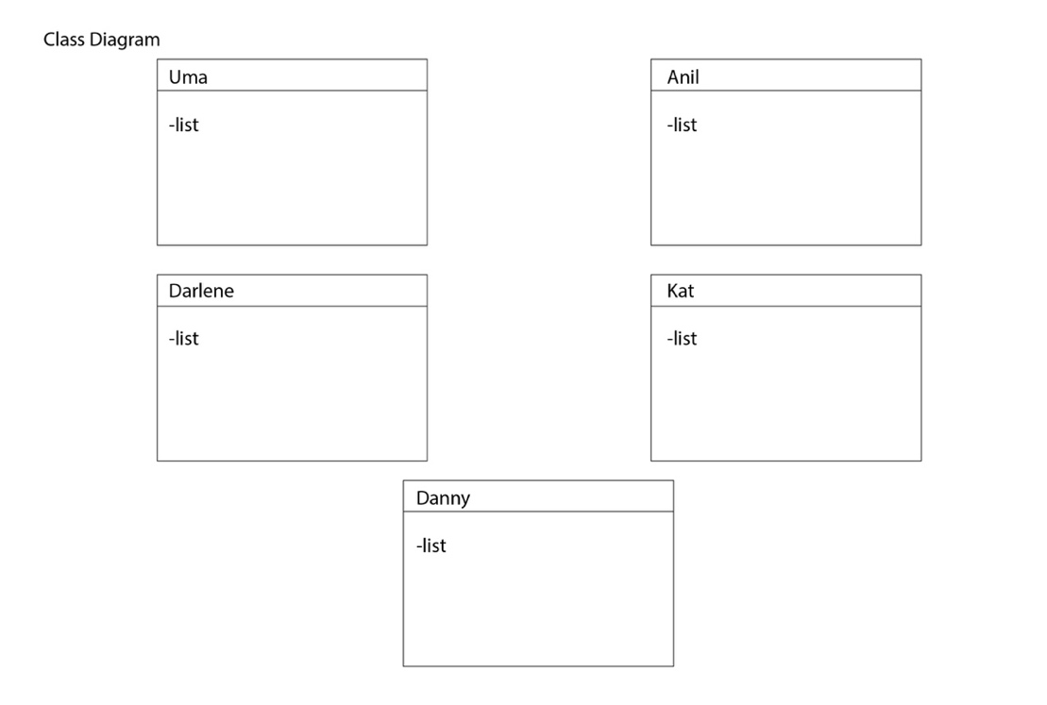

1. **Risks**

|  |  |
| --- | --- |
| a. | Limited experience using JavaScript and Node JS in a web-based application. <https://www.youtube.com/watch?v=PkZNo7MFNFg> |
| b. | Some of the team members would need training on SQL and database programming. <https://www.youtube.com/watch?v=PkZNo7MFNFg> |
| c. | There are fees associated with cloud hosting for an app and a database, as well as load testing to anticipate scalability. <https://cloud.digitalocean.com/> |
| d. | There is potential legal liability for users who treat meal suggestions as medical advice.  <https://www.insurancejournal.com/magazines/mag-features/2016/07/25/420535.htm> |
| f. | There are data privacy issues and a need for terms and conditions, and a privacy policy  <https://www.termsfeed.com/blog/privacy-policies-vs-terms-conditions/> |